Can Tourism contribute to achieving gender equality and women’s empowerment in Bolivia?

Agnes Medinaceli Baldivieso

According to the World Tourism Organization, tourism has the potential to play a key role in the fulfilment of the 2030 Agenda; particularly in the commitment to achieve gender equality, women’s empowerment, and the determination to leave no one behind (UNWTO, 2021).

From a broad perspective, it seems that tourism in Bolivia is already proving to be an ally in the fight for gender equality. In this Andean country, before the pandemic, the tourism sector employed 289,300 women and 90,438 men (AnalisisReal-Latinoamerica, 2018). This means that 76% of people employed in this sector were women. Globally, 54% of people working in this sector were women for the same period (UNWTO, 2021). Hence, it is clear that Bolivia has an advantage compared to other countries (see Figure 1).

This is a positive aspect, but unfortunately it does not give us the whole picture. In the tourism sector in Bolivia there are numerous obstacles and challenges that can potentially backfire against gender equality and women’s empowerment if action is not taken.

Figure 1: Percentage of people employed in tourism who are women, 2018 (%)
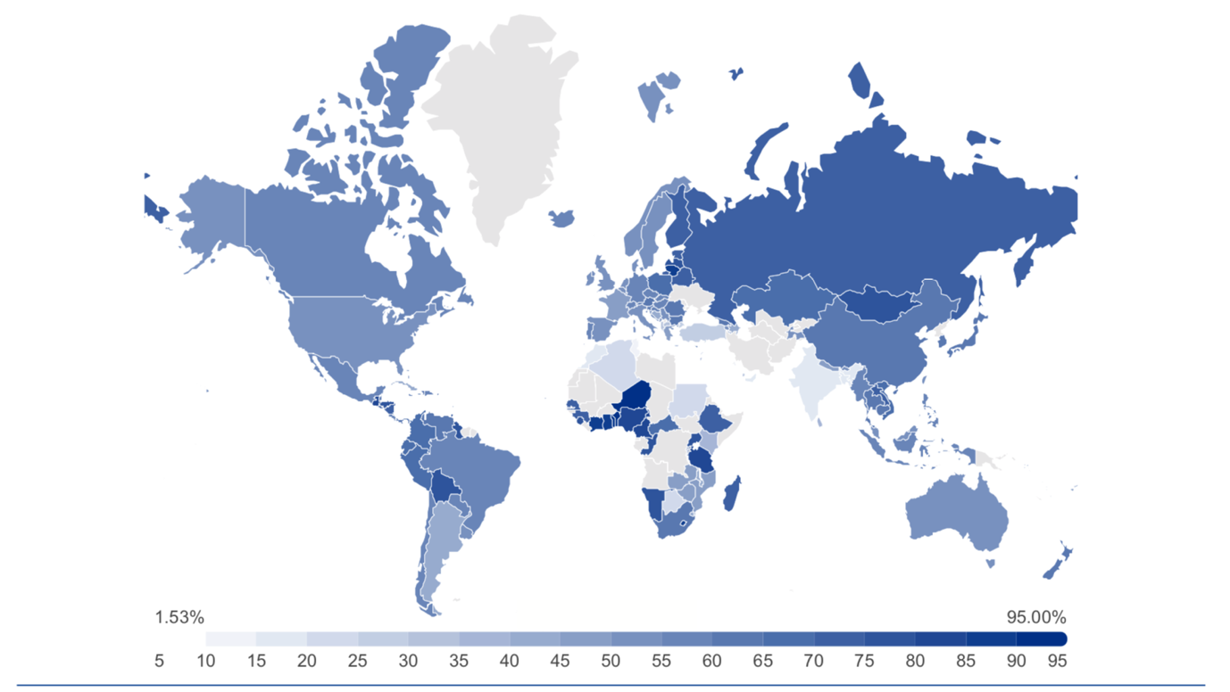
Source: UNWTO (2021; page 10)

A word of caution from Thailand
Before continuing with the Bolivian case, let me briefly cover Thailand’s experience. The history of tourism in Thailand dates back to the Vietnam War, where entertainment businessmen in Bangkok made profits from the frequent arrivals of the US military. When the war ended, Thailand decided to rebuild its economy by promoting the development of mass tourism, following the recommendations of the World Bank (Bishop & Robinson, 1999). However, because Thailand was a long and expensive flight from most countries with populations that enjoyed paid holidays, it did not succeed in attracting families, but rather men traveling alone. This is where the story turns eerie because as a consequence the focus was placed on providing sexual pleasure for these men and exploiting women for this purpose.

Today very little has changed, in spite of the introduction of the Prevention and Suppression of Prostitution Act in 1997. The combination of high levels of corruption, poverty, and familial cultural expectations in this Asian country has allowed this process of exploitation to carry on (Narula, 2019). The sex industry in Thailand contributes approximately 10-12% to the country’s overall GDP (Garrick, 2005), but at what cost? If we were to take sex workers into account, surely more than 70% of people employed in the tourism sector in Thailand would be women, but that wouldn’t brighten up our day. There are currently organisations which are trying to empower sex workers by giving them access to education and changing the narratives surrounding gender equality and shame. But as Narula (2019) points out, sex workers can’t feel or be empowered within a system which is beyond their control and where they are still vulnerable to STDs, violence, and other threats.

What actions can we take in Bolivia to avoid the worst scenarios?
In an ideal world, promoting tourism in Bolivia would give more women decent jobs and thus empower them economically. However, as observed in Thailand, things can go wrong even when there are good intentions. Bolivia also suffers from corruption, poverty, and sexism, so nothing ensures that promoting tourism may not end up exploiting Bolivian women in one way or another.

What can Bolivia do in order to avoid the worst scenarios and promote gender equality and women’s empowerment? The quick answer: study the positive as well as the negative aspects, within different dimensions, of the Bolivian tourism industry to understand it better and promote the implementation of good practices.

To start, we need to comprehend what empowerment means for the women in this industry and how it can be achieved. Empowerment has different definitions, but what unifies all definitions is that they shift the analysis of power from groups that already possess it, to oppressed groups. Kabeer (2020:100), takes the concept of choice as a starting point and defines “power as the capacity to make choices”, pointing out that people who had always had the capacity to decide in their lives are powerful, so they are not empowered. Hence, empowerment is inexorably bound to the status of disempowerment and refers to the processes by which disempowered people gain the capacity to make choices (Kabeer, 2020). Under this framework, can Bolivian women who have a decent job in the tourism sector be or feel empowered if they can’t decide how their earnings will be used because their partners have the final word?

Moreover, we also need to study what gender inequality means for women working in the industry. Most of the time, we automatically tend to think of pay gaps and women’s labour force participation when gender inequality is discussed. But gender inequality involves other aspects. Hence, we should broaden our views. For instance, we need to study the Bolivian ideologies that place women as inferior to men and create inequalities at work. As an specific example, more research about the micro-violence that women in the tourism sector suffer every day, such as when they are asked to wear certain uncomfortable clothes, is needed.

In conclusion, tourism can be an important ally, in terms of gender equality, but we require more thorough research to understand various aspects of inequality and what role they play within the tourism industry as well as within Bolivian households.

References

AnálisisReal-Latinoamérica (2018). El Sistema Económico de los Sistemas Locales: el potencial de los 339 municipios de Bolivia. La Paz, Bolivia: AnálisisReal-Latinoamérica y Fundación Jubileo. Junio.

Bishop, R. & Robinson, L. S. (1999) In the Night Market: Tourism, Sex, and Commerce in Contemporary Thailand. Women’s Studies Quarterly, 27, ½; 32-46. https://www.jstor.org/stable/pdf/40003396.pdf?casa_token=0LO72Gm0blYAAAAA:EuuFRTPLERg60S6Ku9adHlLUXCBwT3K-RY0xGPmDRI7bGE-b6_Ky_dbYswecNfw3DRj2_OTDF_qWqhITGxgzBZWzcwJYqpGdfeyR-rKKtdAXFBHVGZJIGw

Garrick, D. (2005) Excuses, Excuses: Rationalisations of Western Sex Tourists in Thailand. Current Issues in Tourism, 8 (6): 497-509. Available online: https://www.tandfonline.com/doi/abs/10.1080/13683500508668233

Kabeer, N. (2020) Three faces of agency in feminist economics: capabilities, empowerment and citizenship. In: Berik, G. and Kongar, E (Eds.), Handbook of Feminist Economics. New York: Routledge.

Narula, A. (2019) What you want to see is what you get: realities, representations, and reputations of sex tourism in Bangkok. The London School of Economics and Political Science. Engendering Blog. Available online: https://blogs.lse.ac.uk/gender/2019/10/24/what-you-want-to-see-is-what-you-get-realities-representations-and-reputations-of-sex-tourism-in-bangkok/

UNWTO (2021) Global Report on Women in Tourism (Second Edition). Available online: https://www.e-unwto.org/doi/book/10.18111/9789284422753

